**1.Create and inject the seed**

Inject the URL: <https://en.wikipedia.org/wiki/C9_League> into database.

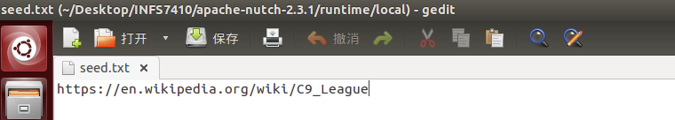

Open compass to see the seed URL.

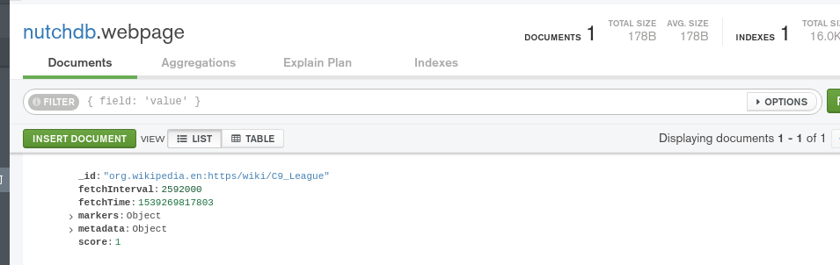

**2. Generate/fetch/parse/updated cycle**

Use Nutch to crawl webpages by four generate/fetch/parse/updated cycle

First round: Top 50

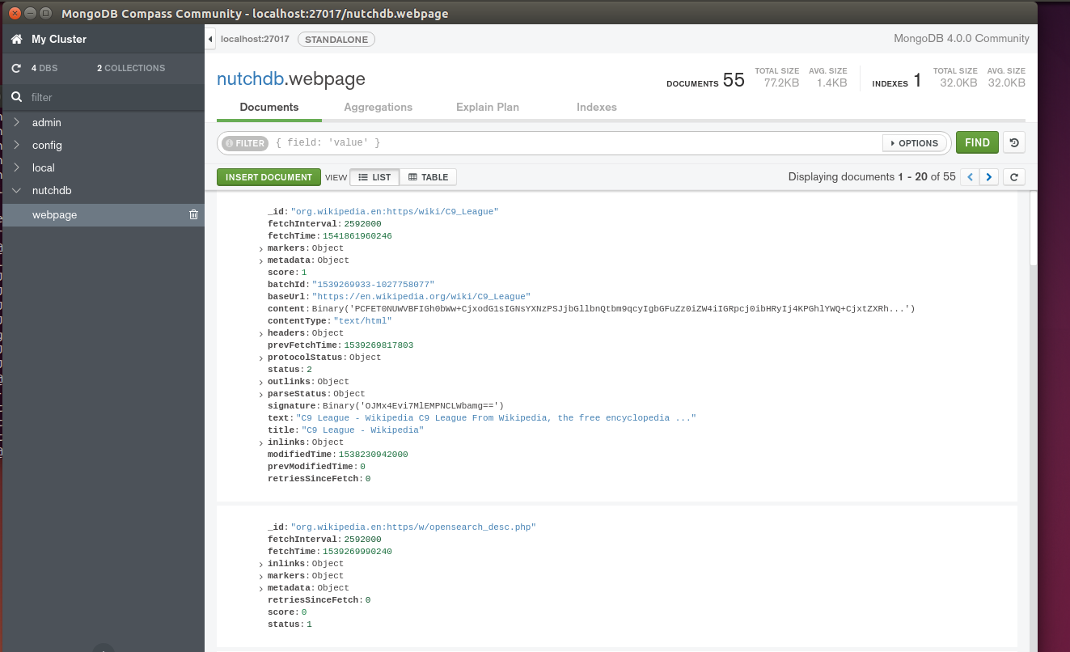

Second round: Top 100

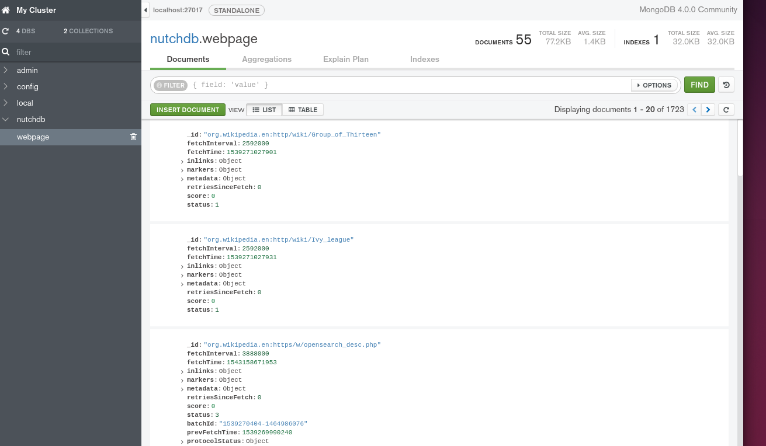

Third round: Top100

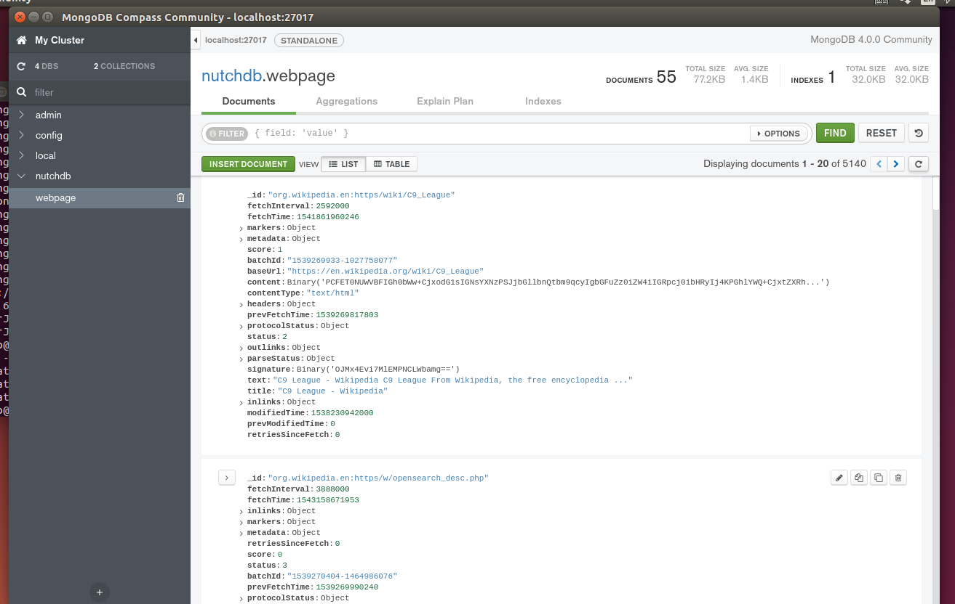

Fourth round: Top150

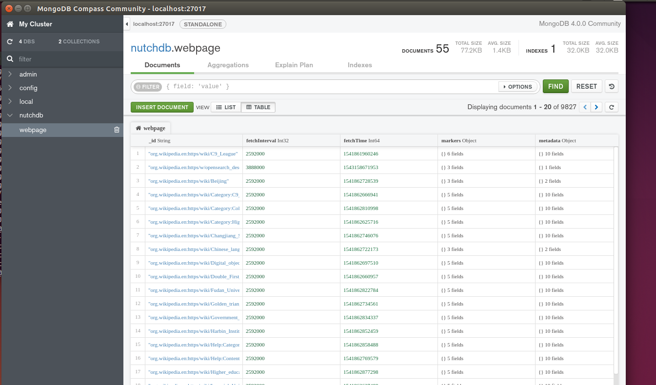

**3. Check the number of pages which was successfully fetched**

